**Proposal For Autonomous Underwater Sensor-Cleaning Robot**

**Re: ﻿RFP-VN120-202301**

Submitted to

**Gillian Saunders, Project Supervisor**

by

**Arfaz Hossain, Project Lead**

**Table Of Contents**

1. Proposal Background 3
2. Design Proposal for the Prototype Robot 3

2.1 Omni-Directional Axial Design 5

2.2 Sensor Integrated Control System 6

2.3 Surface Cleaning Mechanism 8

2.4 Sustainability in the design 8

1. Bills of Materials and Timeline 9
   1. Estimated Costs 10
   2. Project Timeline 11
2. Final Consideration 12
3. References 12

1 Proposal Background

Ocean Networks Canada (ONC) is seeking proposals for the development of an autonomous underwater robot capable of cleaning and positioning objects on underwater cameras and sensors. As part of the observatories, ONC operates world-leading ocean monitoring systems that collect a wide range of data, including water quality, biodiversity, and marine environment information, and provide live video feeds of conditions related to the ocean floor, seismology, and biology. However, the observatories' cameras and sensors can be obscured by biofouling, sedimentation, and falling debris, impacting data collection and monitoring. To address this issue, ONC is inviting external proposals for the research, design, construction, development and testing of a prototype robot that can locate an object emitting a specific IR signal, within a constrained search area, position a simulated cleaning device on top of it, and signal the completion of the task. [6]

The prototype robot must be environmentally sensitive and capable of maneuvering without causing damage to the surrounding objects. According to Ocean Networks Canada, the automated systems should include designs for small-scale models that can simulate the prototype's function in a dry lab environment.[6] The robot's onboard sensors and cameras should be capable of collecting and transmitting data on the robot's movements, the target's location, and other environmental variables. The proposed design should factor in the underwater environment's unique challenges, including light absorption, pressure, and temperature. [6]

2 Design Proposal for the Prototype Robot

Our initial design for the robot features a legged, multi-vectored spherical design with a six-axis torque sensor at its center. The torque sensor, like those used in our previous autonomous robotic systems, allows for precise maneuvering of the robot through controlling its longitudinal and lateral motion, as well as cruising motion. This design ensures safe movement in the sensitive ecology of the underwater environment. We have incorporated a sensor integrated control system that allows for remote operations and monitoring in case of any accidents or emergencies, ensuring safety and flexibility during underwater missions. Our design is also equipped with a set of external Infrared sensors in the top-most, a set of proximity, motion, and imaging sensors in the bottom-most as well as a pair of torque sensors in the peripheral modules outside the central waterproof compartment. Our design also incorporates a robust and sustainable power supply system, featuring a central waterproof compartment that houses a set of rechargeable batteries. This modular design ensures a long-lasting and sustainable operation of the 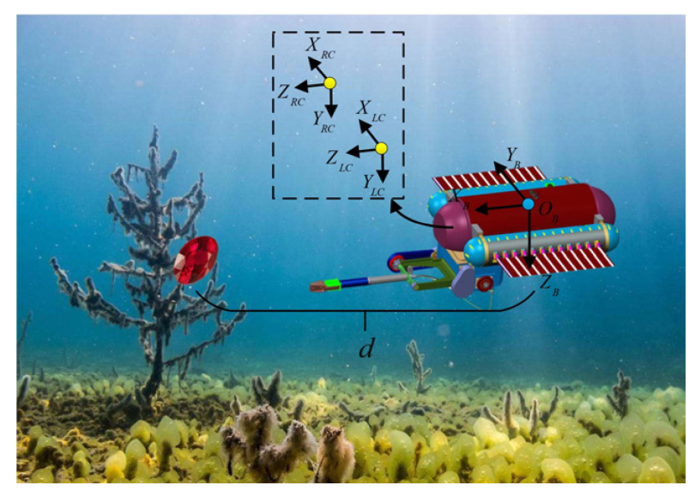robot, without the need for a frequent recharging or replacement of batteries.

Figure: A Target Located Using Sensor Data Collection System

[Image taken from our last *terrain-oil* project] [3]

2.1 Omni-Directional Axial Design

The main key design feature of our prototype design will be the six-legged axial design, which will be consisted of six external peripheral compartments around the central waterproof compartment. [2] The peripheral compartments will provide additional space for the integrated sensor system, wirings, circuit boards among other electrical equipments tailored for the surface cleaning mechanism. This integrated sensor and wiring settings can be customized for a wide variety of underwater operations, but the current setting is specifically designed for this proposal. The waterproof compartment (central cylinder bin), which is protected by an annular support frame, is suspended from the top of the shell by several 140-mm short screws, ensuring an even distribution of weight. The annular support frame will be designed to provide additional stability and durability of the waterproof compartment, ensuring no leaks of water inside.

Figure: Central Waterproof Compartment, designed to withstand leaks and pressure [1]

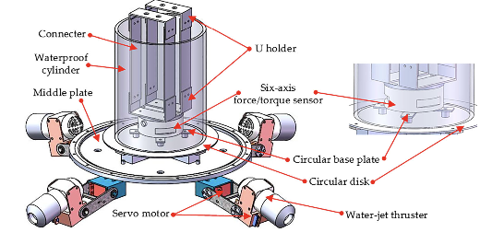The central waterproof bin is a crucial element of the prototype’s design, which houses the rechargeable batteries and the main control boards among other core electrical components. A sealing cover on top of the bin would provide an easy access to these components inside the compartment. This prototype has been designed with sustainability and reusability in mind, much like a Vex Robot, and incorporates a modular approach to its design.[2] This modular approach enables reusability and sustainability, which would allow our robot to be repurposed for different tasks simply by swapping out specific sets of equipment in the six peripheral compartments.[2]

Figure: The Initial conceptual design of the multi-vectored spherical robot

[Image taken from our last *terrain-oil* project] [2]

2.2 Sensor Integrated Control System

The control system will be a critical component of our underwater robot, providing safety, flexibility, and precise remote control when in operation. Our control system will be integrated with many different types of sensors, mainly infrared, imaging, motion, depth, and proximity sensor to help enable remote operation and monitoring and allow operators to safely monitor its coordinates, depth, propulsion rate among other operation modules when in underwater. One of the key features of the integrated sensor system is the integrated torque sensor, which allows for precise control of the robot's movement. This sensor measures the force and torque of each of the robot's propellers, providing real-time feedback to the operators about the robot's speed, direction, and orientation. With the torque sensor, operators can control the robot with great precision, enabling it to perform complex movements and navigate through narrow spaces in such a way that does not harm the surrounding ecology.

The integrated system is composed of several subsystems, which mainly includes the electrical (sensor) system, mechanical, and propulsion systems:

|  |  |  |  |
| --- | --- | --- | --- |
| Electrical System | | Mechanical System | Propulsion System |
| 1 | The electrical system is a critical component of the robot's control subsystem and includes the control unit, sensors, communication unit, and execution unit. [4] | The axial design of the robot, with six peripheral modules and a central waterproof cylinder, provides stability and flexibility for a wide range of underwater missions. | The propulsion system is a unique feature of our robot, which uses only four propellers. Each propeller is connected with the central plate at the bottom of our central compartment (waterproof bin). [2] |
| 2 | The use of sensors, such as the torque sensor, allows for precise control of the robot's movements, making it well-suited for underwater operations. | The waterproof cylinder houses the batteries, control boards, and other electronic components and is designed for easy access and maintenance. [2] | The electrical and mechanical system of our robot enables each of the four propellers to move rightward and leftward to a degree along the central (middle) plate, allowing it to navigate underwater. |
| 3 | The sensor integrated architecture of our system allows for precise movement and operation of the robot. | The support frame surrounding the waterproof cylinder provides additional stability and support for the robot. | The system also provides stabilization of the robot's attitude, flexibility and mobility, rotation, and position control.[2] |

Figure: Degrees of complex locomotion throughout the central plate with the help of 4 propellers.

[Image taken from our last *terrain-oil* project] [4]

2.3 Surface Cleaning Mechanism

Our prototype will be equipped with three different types of sensors for the surface cleaning mechanism: infrared, imaging and proximity sensor. Infrared and imaging sensor will help us guild our robot from remote systems to our target location, whereas our proximity sensor will help us with the co-ordinates and with our cleaning mechanism. Once the target is located, the robot will get close to the object and activate its surface cleaning mechanism.[3] The propulsion system will provide the necessary mobility and flexibility to navigate around the target object and clean its surface. Once the cleaning is complete, the robot will signal the completion of the task.

2.4 Sustainability in the Design

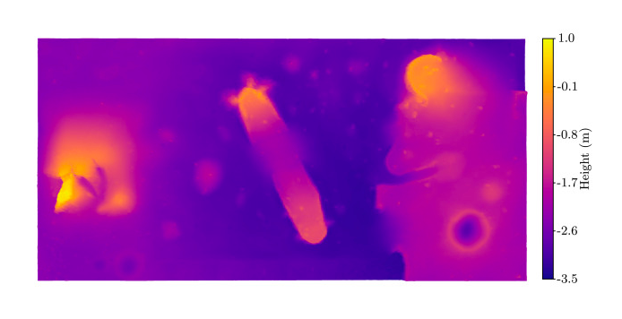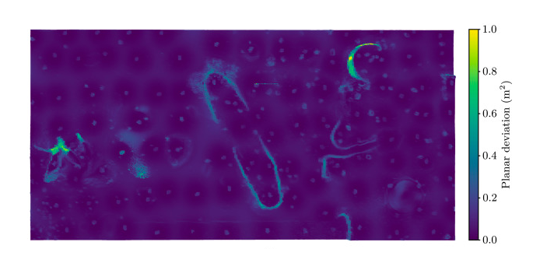The modular design of our robot is an essential element in achieving our sustainability goal. The modularity allows us to easily replace and upgrade the robot's components, minimizing the need for complete replacement and reducing waste. We are also planning to use environmentally friendly materials for our robot's construction, such as biodegradable and recyclable plastics, to reduce its ecological footprint.

Figure: Ocean Terrain Mapping with the use of Infrared and Imaging Sensor Technologies [5]

The robot's electrical, integrated sensor and propulsion system is designed to minimize its impact on the surrounding environment and ecology. The multi-vectored propulsion system reduces the number of propellers needed for our axial design, which would significantly decrease the amount of turbulence generation and noise created. s

Figure: Ocean Terrain Mapping with the use of Infrared and Imaging Sensor Technologies [Image taken from our last *terrain-oil* project] [5]

In addition to the design features, the robot's integrated sensor system will be optimized for energy efficiency. The control system will be designed to consume low power, which prolongs the robot's operational time and reduces its energy consumption. This energy efficiency, coupled with the modularity and eco-friendly materials, will allow our prototype to meet our sustainability goals and minimize its impact on the environment.

3 Bills of Materials and Timeline

The completion and testing of the prototype will require approximately four months. However, we have a head start as we already have most of the equipment needed for the prototype from previous projects.

3.1 Estimated Costs

This is an estimated cost for the complete design and manufacture of one prototype, which includes all the necessary equipments, testing, designing following proper regulations. Since we have most of the equipment from some of our previous projects, we have to either outsource the remaining components based on our project-specific needs or designed from scratch using 3D modeling. Our design team has estimated the cost and timeline required to complete the project.

|  |  |  |
| --- | --- | --- |
| Components for the Prototype Design | Quantity | Approximate Cost (CAD) |
| Waterproof Cylinder Bin* | - | $5,200 - $7,500 |
| Propulsion System with Central Plate* | - | $1,000 - $3,500 |
| Cleaning Unit* | - | $3,500 |
| Control unit* | - | $1300 - $2400 |
| Propellers | 4 | $100 - $150 |
| Infrared Sensors | 5 | $325 - $375 |
| Proximity and Motion Sensors | 5 | $500 - $600 |
| Imaging Sensor | 1 | $200 |
| Torque Sensors | 2 | $1,000 - $1,200 |
| External Modules | - | $575 - $675 |
| Central Frames | 13 | $800 |
| Rechargeable Batteries | 12 | $400 - $500 |
| Miscellaneous * | - | $12,000 |
| Total Range (CAD) | | $25,000 - $31,500 |

[ * ] This is a list of components that have either been manufactured or for which the budget has not yet been finalized, as the system will consist of a number of equipment that has not yet been determined.

3.2 Project Timeline

We estimated that it will take us approximately 4 months to complete the project. Once the design and assembly of the prototype robot are complete, we will begin testing the sensors and control units. After final testing and validation of the prototype, we will proceed to a final version of the prototype, which will incorporate all the necessary improvements or modifications based on the design analysis, simulation tests, and the underwater sensor and system test. Our main engineering teams will include a Mechanical and Materials Engineering Team, a Software Integrated Systems Team, an Electrical Engineering Team, a Design and Management Team. The progress of our project will be tracked by this Gantt Chart:

4 Final Consideration

Our *Design and Management* team has dedicated significant effort to ensure that our design proposals meet the necessary requirements and budget limitations while also addressing the unique challenges posed by this project. By incorporating energy-efficient and environmentally conscious features into our designs, we aim to demonstrate our commitment to sustainability and responsibility. We believe that the integration of these features will showcase our company's innovative approach to engineering and align with the values of the Oceans Networks Canada (OCN). We are excited to have the opportunity to develop and test the chosen prototype to fulfill the objectives and needs outlined in the request for proposals. I look forward to receiving your feedback on the proposed design concept for the prototype robot, and am ready to start the selection, research, and development process upon approval of the optimal design for this project.

5 References

1. R. An, S. Guo, Y. Yu, C. Li, and T. Awa, “Multiple Bio-Inspired Father–Son Underwater Robot for Underwater Target Object Acquisition and Identification,” *Micromachines*, Dec. 2021 [Online] *dx.doi.org/10.3390/mi13010025*
2. Y. Li, S. Guo, and Y. Wang, “Design and characteristics evaluation of a novel spherical underwater robot,” *Robotics and Autonomous Systems*, vol. 94, pp. 61–74, Aug. 2017 [Online] *doi.org/10.3390/mi13010025*
3. H. Xing, S. Guo, L. Shi, X. Hou, Y. Liu, and H. Liu, “Design, modeling and experimental evaluation of a legged, multi-vectored water-jet composite driving mechanism for an amphibious spherical robot,” *Microsystem Technologies*, vol. 26, no. 2, pp. 475–487, Jul. 2019 [Online]

doi.org/10.1007/s00542-019-04536-7

1. R. Wang, S. Wang, Y. Wang, M. Cai and M. Tan, "Vision-Based Autonomous Hovering for the Biomimetic Underwater Robot—RobCutt-II," in IEEE Transactions on Industrial Electronics, vol. 66, no. 11, pp. 8578-8588, Nov. 2019 [Online]

*doi.org/10.1109/TIE.2018.2886755*

5. J. D. Hernández *et al.*, “Autonomous Underwater Navigation and Optical Mapping in Unknown

Natural Environments,” *Sensors*, vol. 16, no. 8, p. 1174, Aug. 2016 [Online]

*doi.org/10.3390/s16081174*

6. Ocean Networks Canada, “RFP-VN120-202301, Prototype Designs For An Autonomous Underwater Sensor-Cleaning Robot”, [*https://www.oceannetworks.ca/research-and-development/current-developments/proposal-requests/RFP-VN120-202301*](https://www.oceannetworks.ca/research-and-development/current-developments/proposal-requests/RFP-VN120-202301l)